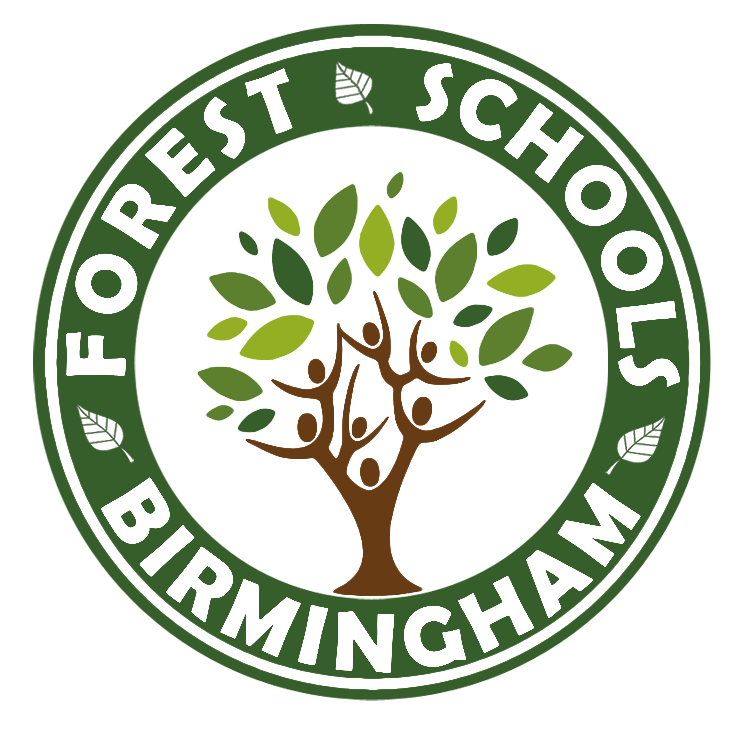

In association with
Outdoor Learning UK

OCN Level 2 Forest Schools Award
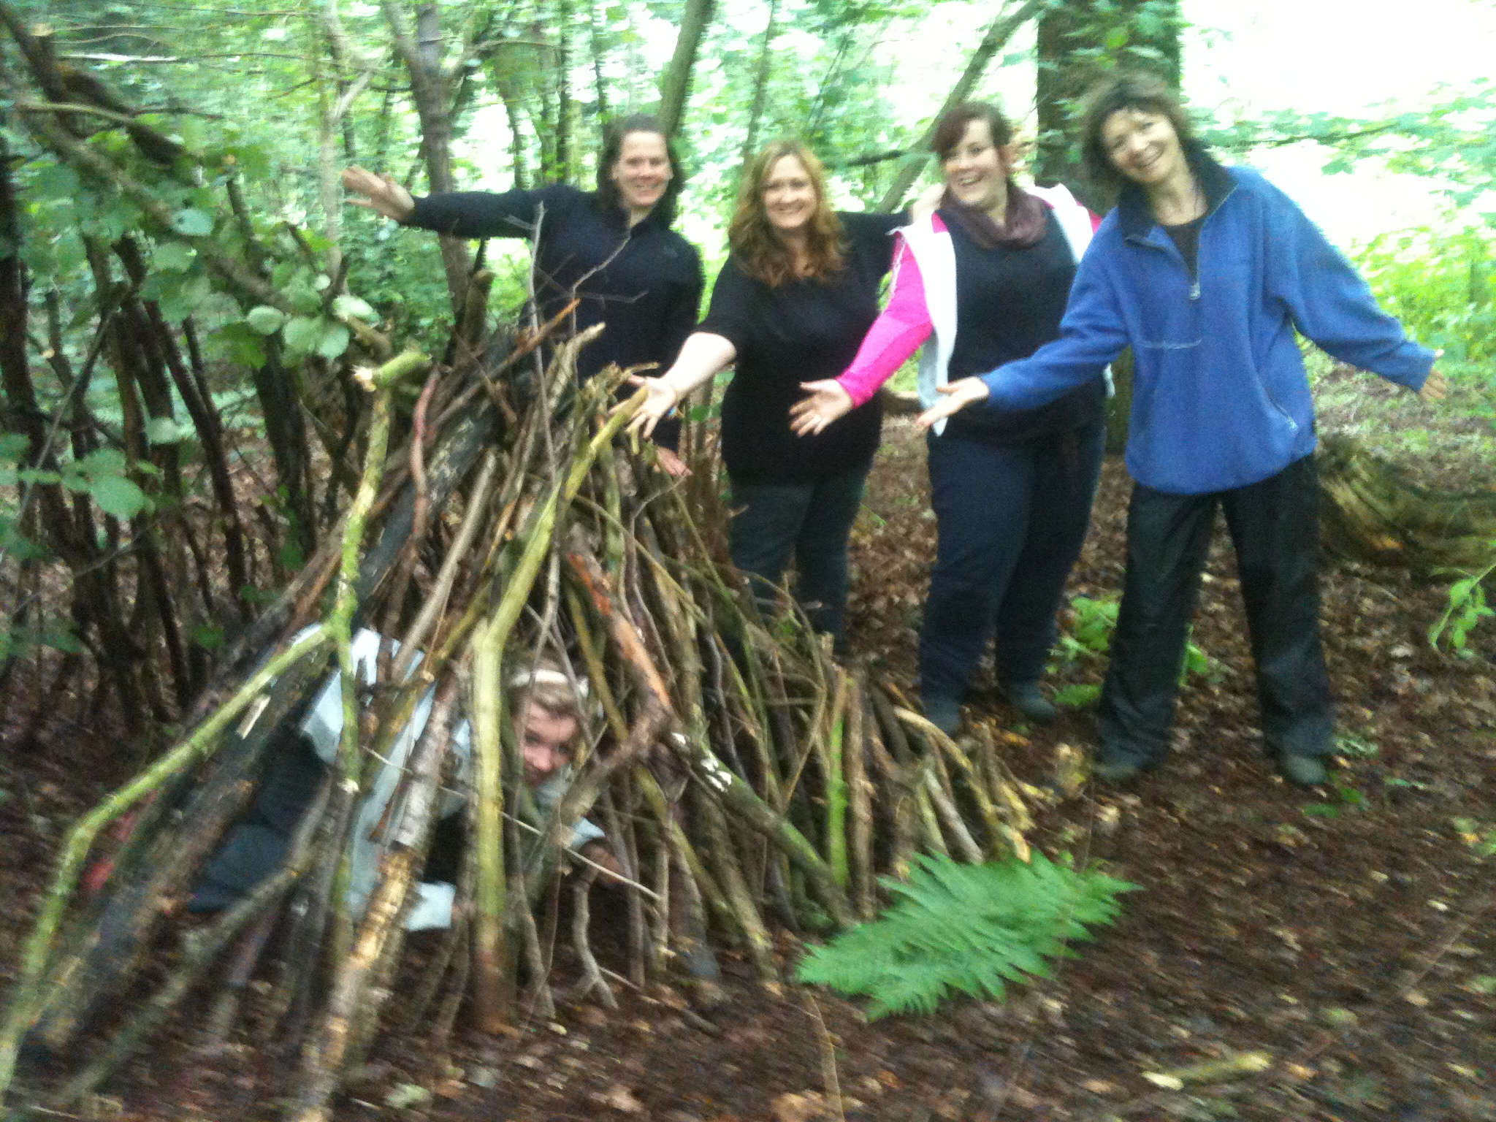
Here at Forest Schools Birmingham CIC, we are more than just a training company, we are a community and a support network. We intend to support you throughout your practice; whether that is help planning a site, support in your setting, INSET, providing supporting practitioners or just a place to ask questions and advice. We are here for the journey.

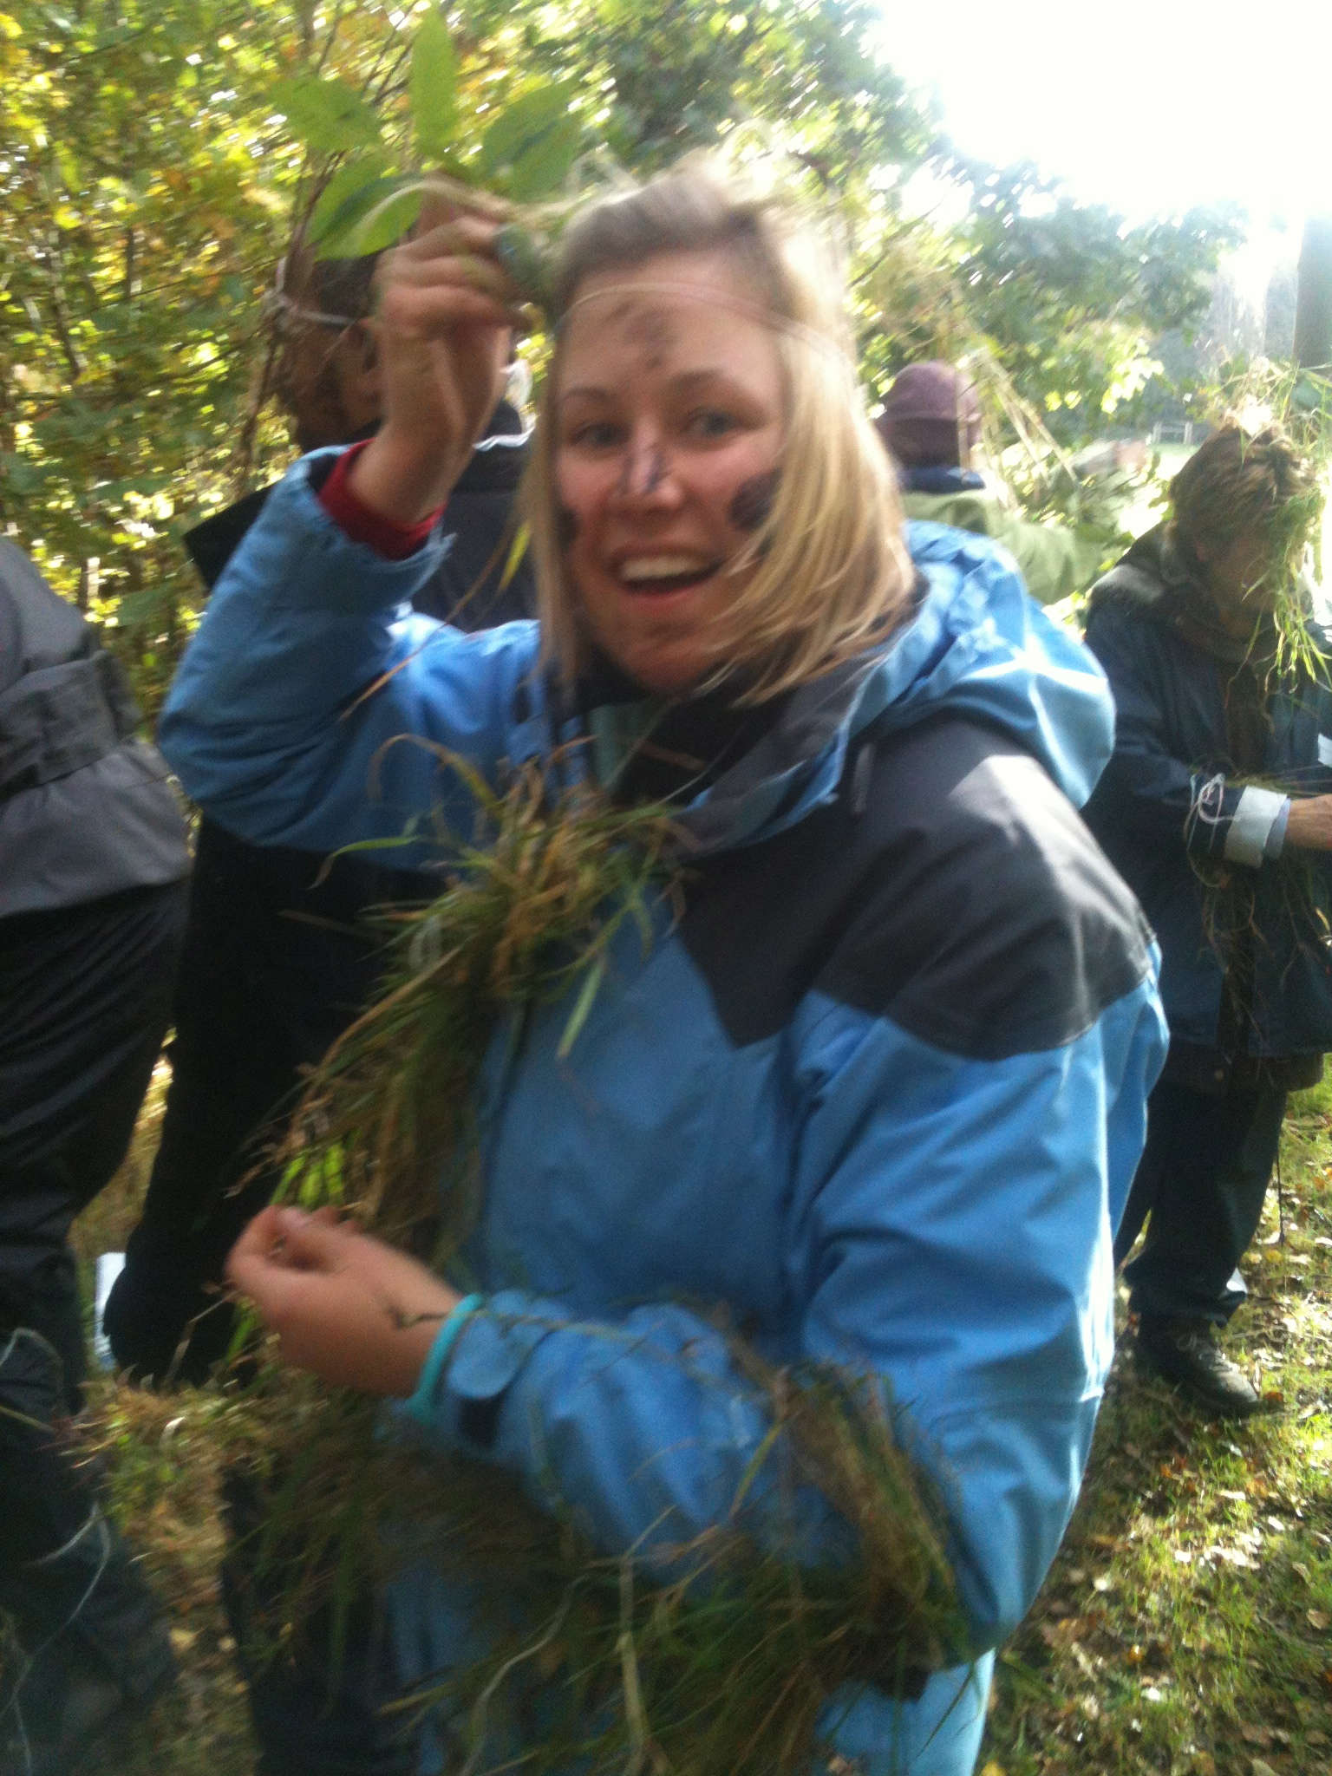

Forest School training is centred around three key areas:

- Supporting the learner’s empathy with the Natural World.
- Scaffolding the child or adult’s coping strategies and underpinning good emotional, mental and physical health.
- Ensuring that the ‘Outdoor Classroom’ is used as often as possible.

Forest School is all about choosing a lifestyle that brings about and sustains positive change.

The Level 2 Forest School training is suitable for individuals who have a love of the outdoors and who intend to either:
- assist with Forest School sessions run by a Level 3 Forest School Practitioner
- work in Early Years / Nursery where you will be unlikely to intend to use tools and fire within your setting – if you would like to use fire and tools in your setting please talk to us about the Level 3 accreditation ASAP as you may want to upgrade your training.
- Parents/carers who would like to get the most of the outdoors when they are out in nature with their family.

You do not have to hold any other qualification and this course is suitable for people from a variety of settings.

Our Forest Schools training is of the very highest standard with practical skills and safety at its backbone, underpinned with sound and engaging development theories. Not only are we providers of training, we are also one of the longest standing and most successful deliverers of Forest School programmes to children in the UK. We have worked with 550+ schools over the last 19 years.

We are also an award winning charitable business, having been awarded ‘Birmingham’s Greenest Business’ two years consecutively by the Birmingham Green Commission, Birmingham’s best Food Growing Project, we were invited to Downing Street as part of the Prime Minister’s Big Society Vision and we are featured in The Parliamentary Review 2020.

Training consists of a 5 day initial training period and then you will then have 3 months to complete a short portfolio of evidence, including assisting at 3 Forest School Sessions with a Forest School leader. You will need to find a Level 3 Practitioner in your area to assist, but if this proves problematic, we are at hand to help facilitate this for you.

The training is outdoor based where we have you ‘doing’ as you learn; this way our trainees come away with a practical, kinaesthetic working knowledge of all aspects of Forest Schools, including sound practical skills and a thorough understanding of the theories and benefits relating to good Forest Schools practice.

If you have any questions about the course content, please do not hesitate to contact us.

